* **CAREER OBJECTIVE**

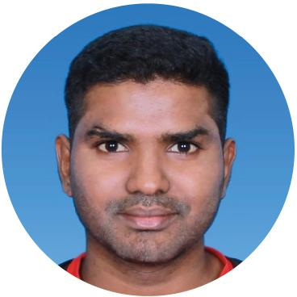

**LAKSHMAN**

**S/O RAMANUJAM**



+6014 - 274 1092



No 13, Jalan Sri Jaya 5,  
Taman Sri Jaya,  
86000 Kluang, Johor

[Iakshman.ramanujam04@gmail.com](mailto:Iakshman.ramanujam04@gmail.com)

IC No : 920517 - 01 - 5259

Age : 24

Date of Birth : 17 May 1992

Gender : Male

Nationality : Malaysian

Race : Indian

Religion : Hindu

Marital Status : Single

To acquire a professional position in a creative and challenging environment, where I can utilize my educational and job experience and constantly learn, seek and apply my knowledge with commitment to the company's excellence. Some of other objectives are:

* Adapting to working environment
* Understanding Telecommunication and Electronic field works in industry.
* Learning to apply knowledge gained from University at workplace.
* Improving communication skills with other employees.
* **BACKGROUND EDUCATION**

**2016 - Tbilisi Teaching University Gorgasali, Georgia**

Professional Diploma in Manufacturing Management

**2011 - 2016 - Multimedia University, Cyberjaya, Selangor** Bachelor of Engineering (Hons.) ELectronic Majoring in Telecommunications

* **WORKING EXPERIENCE**

**March 2015 - May 2015**

- Internship (CTC Integrated Software Engineering  
Sdn Bhd) Kluang, Johor

* **SKILLS**

Excellent analytical and leadership skills and technical report writing capabilities. Team player and self-motivator with superb oral and written communication skills. High level of planning, organizing and management skills and decision making ability. Willing to work with and learn new equipment and processes.

Language: Spoken Written

Bahasa Malaysia 9 9

English 9 9

Tamil 9 9

* **REFERENCE** Proficiency Level 0 - Poor 10 - Excellent

**Yew Kuen Ying**

Assistant General Manager

CTC Integrated Software Engineering Tel : (H/P) +607 - 772 0106